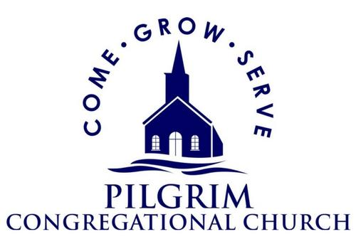
P. O. BOX 247
HARWICH PORT, MA 02646
508-432-1210
PILGRAM CONGREGATIONAL CHURCH
SCHOLARSHIP APPLICATION
Return to the Pilgrim Congregational Church office by June 1, 2023
Applications for Continuing Education will be considered on a rolling basis
Date:
Name:
Address:
Phone:
E-mail:
Parent/Guardian:
High School Attended/Graduation Year (if applicable):
College or Training Major or area of work/study, if decided:
Expected first semester or course completion date:
Volunteer Activities/Involvement in /Relationship to Pilgrim Congregational Church, if any, and to the community:

Personal Essay
Please write a short essay (no more than 300 words) about your involvement at school and in your community (Harwich, Cape Cod, Massachusetts, the World)..

